Introduction to Computing

Lab 14



Topic: Arrays

Faculty of Information Technology

Task 1:

Write a C++ program in which, read a character array of size 10 as input from user. Display those indexes which contain vowels (a,e,i,o,u) on console.

Sample Output:

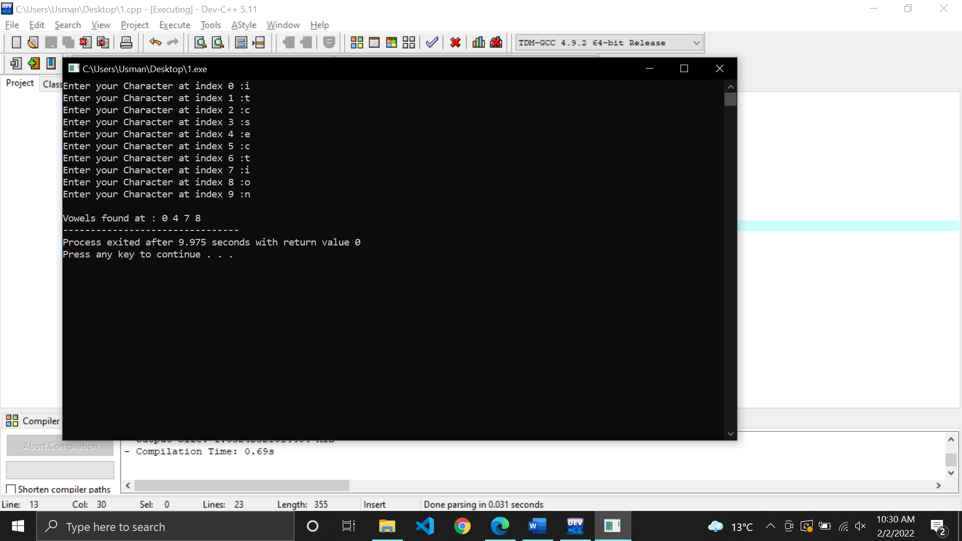

Task 2:
Write a C++ program to find the repeating characters in a given array of characters.
Sample Output:
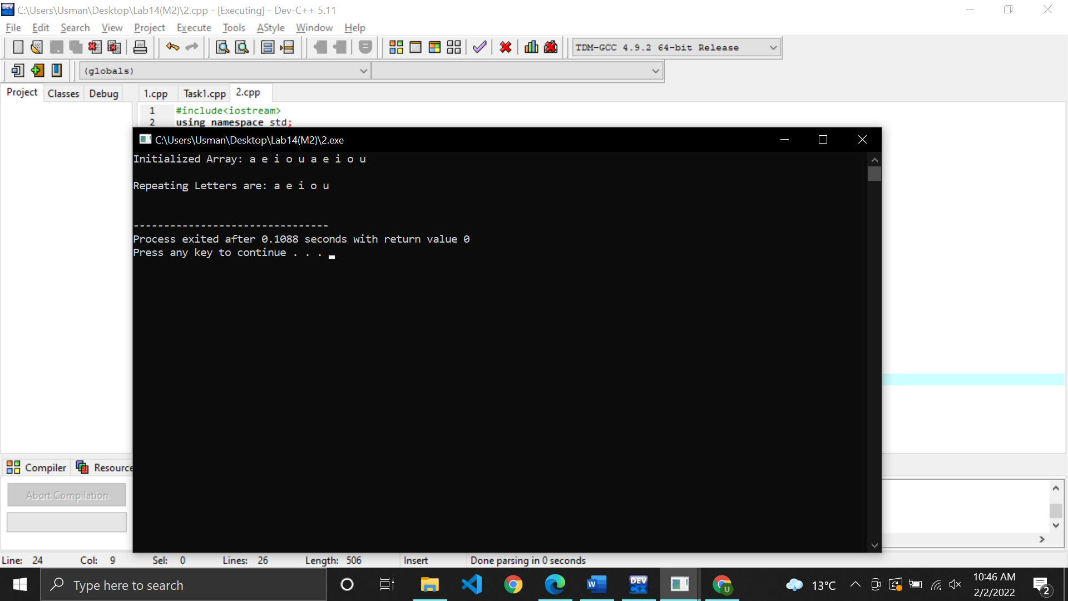

Task 3:

Write a C++ program that initialize two arrays. Now display all the elements of both arrays and also print on screen these arrays are same or not.

Sample Output:

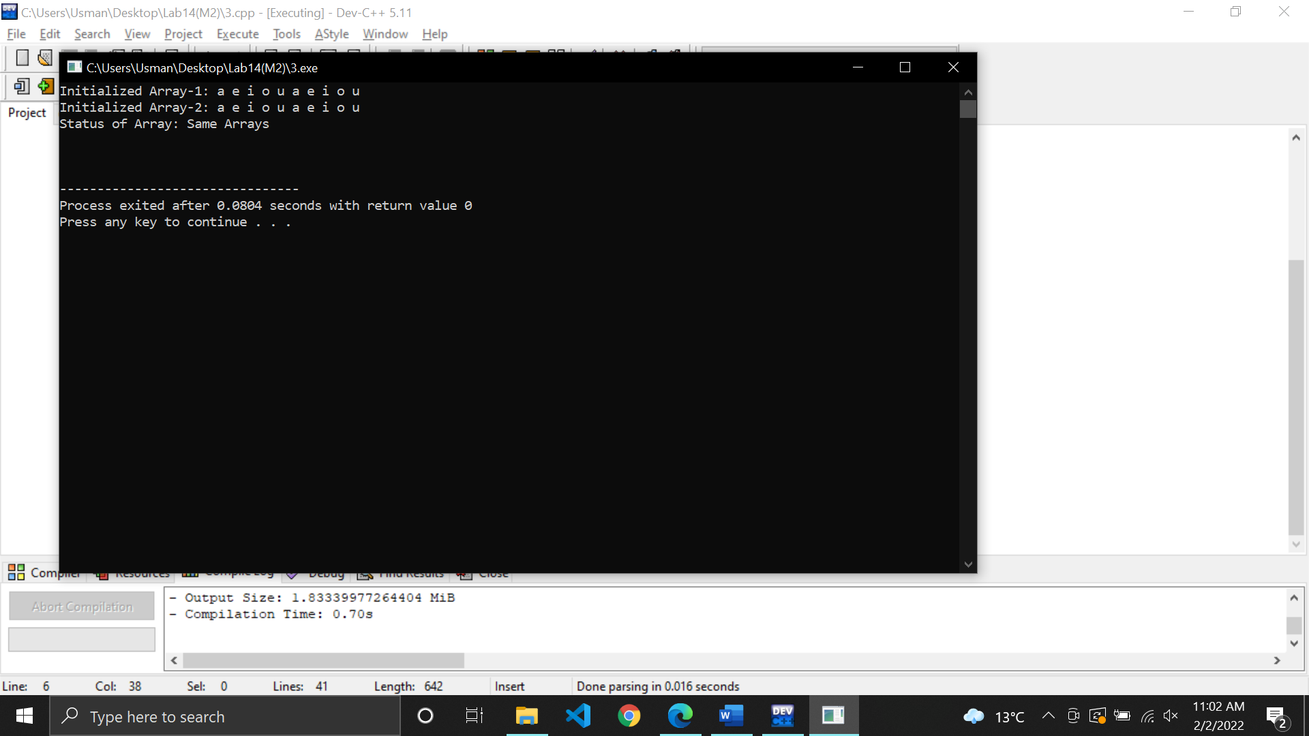

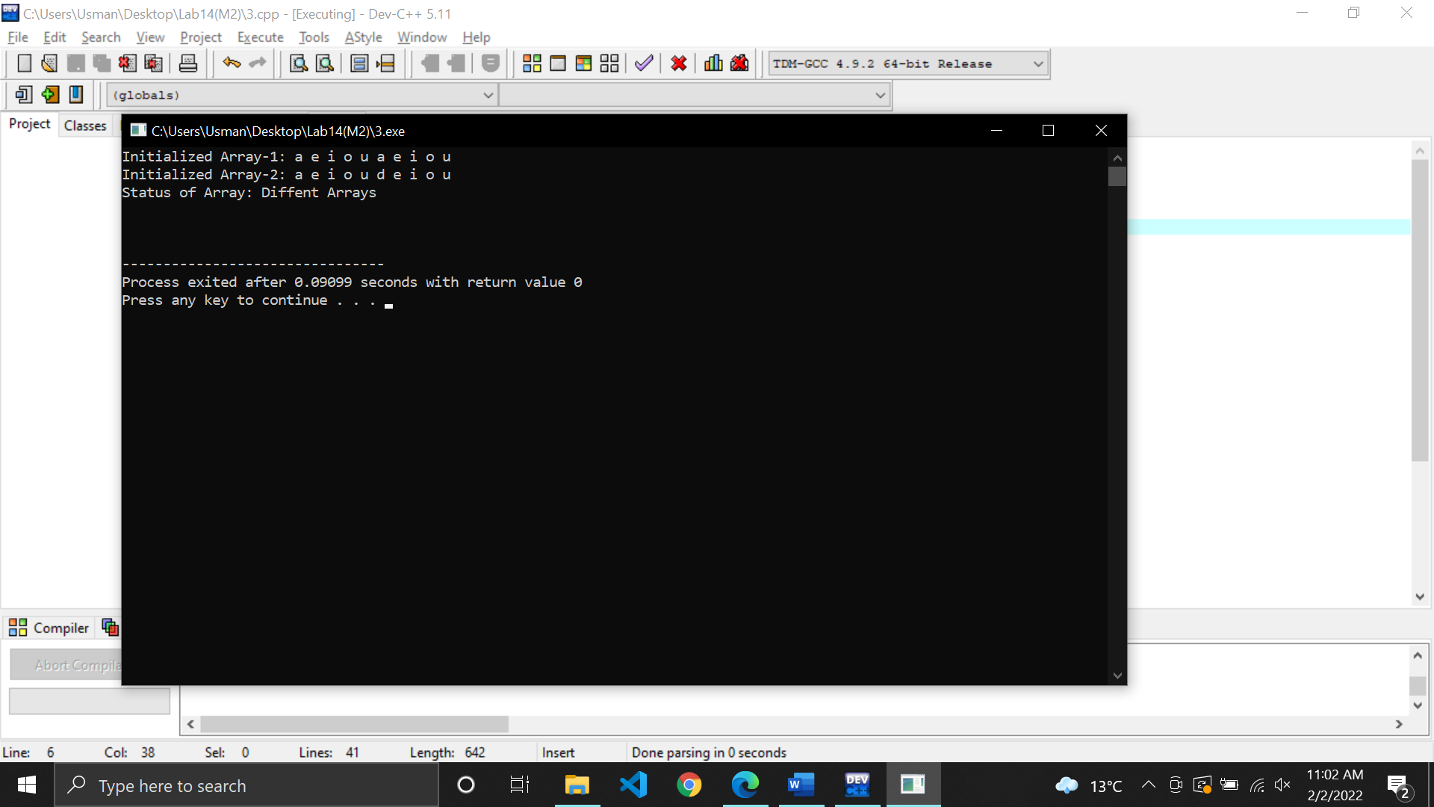

Task 4:
Write a C++ program that ask user a character and search that in the array. If character found print the character and index number on console otherwise print number not found.

Sample Output:

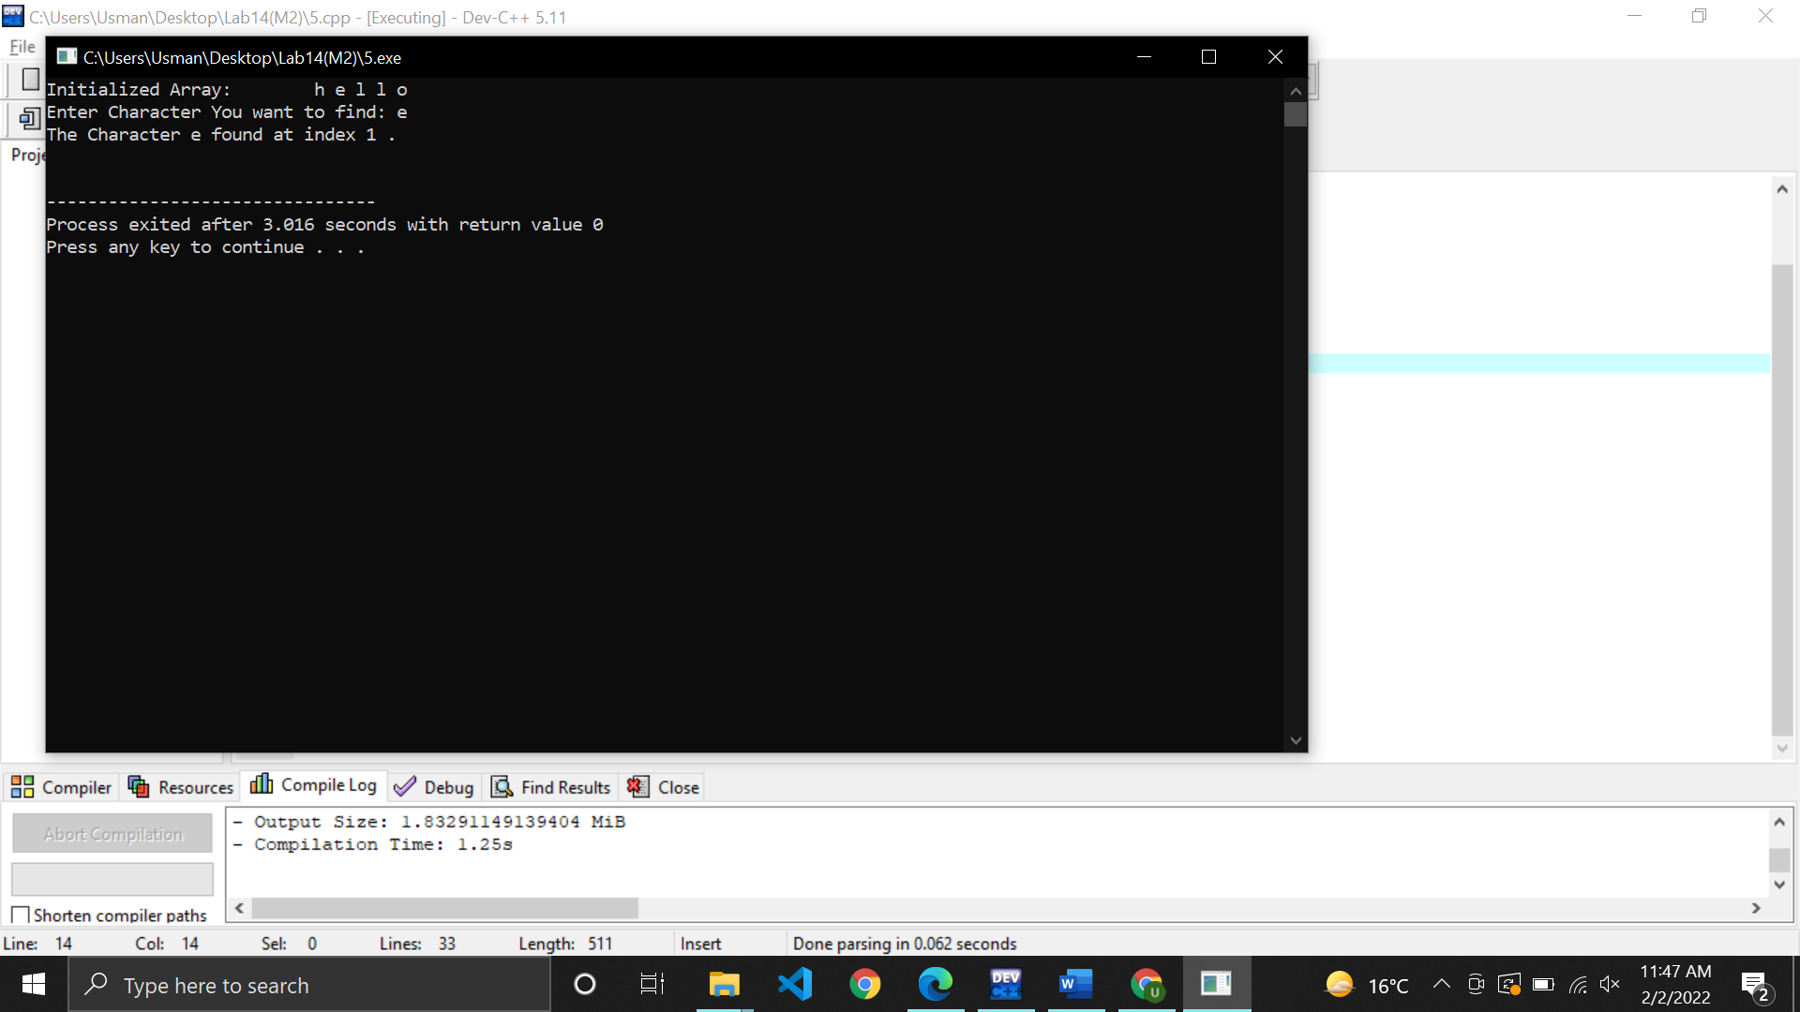

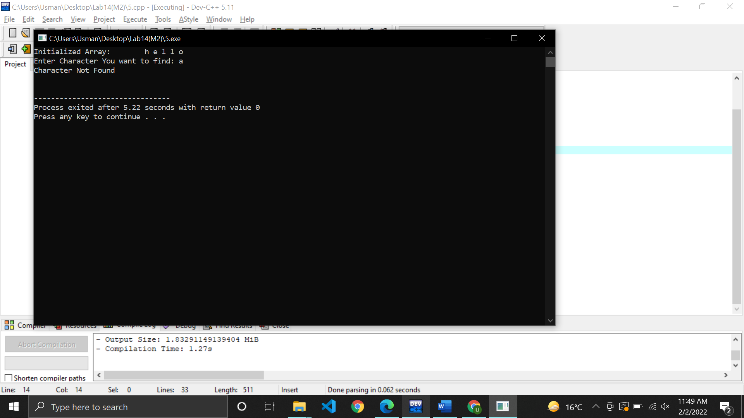

Task 5:

Write a C++ program in which, read a character array of size 10 as input from user. Display the input on console.

Sample Output:

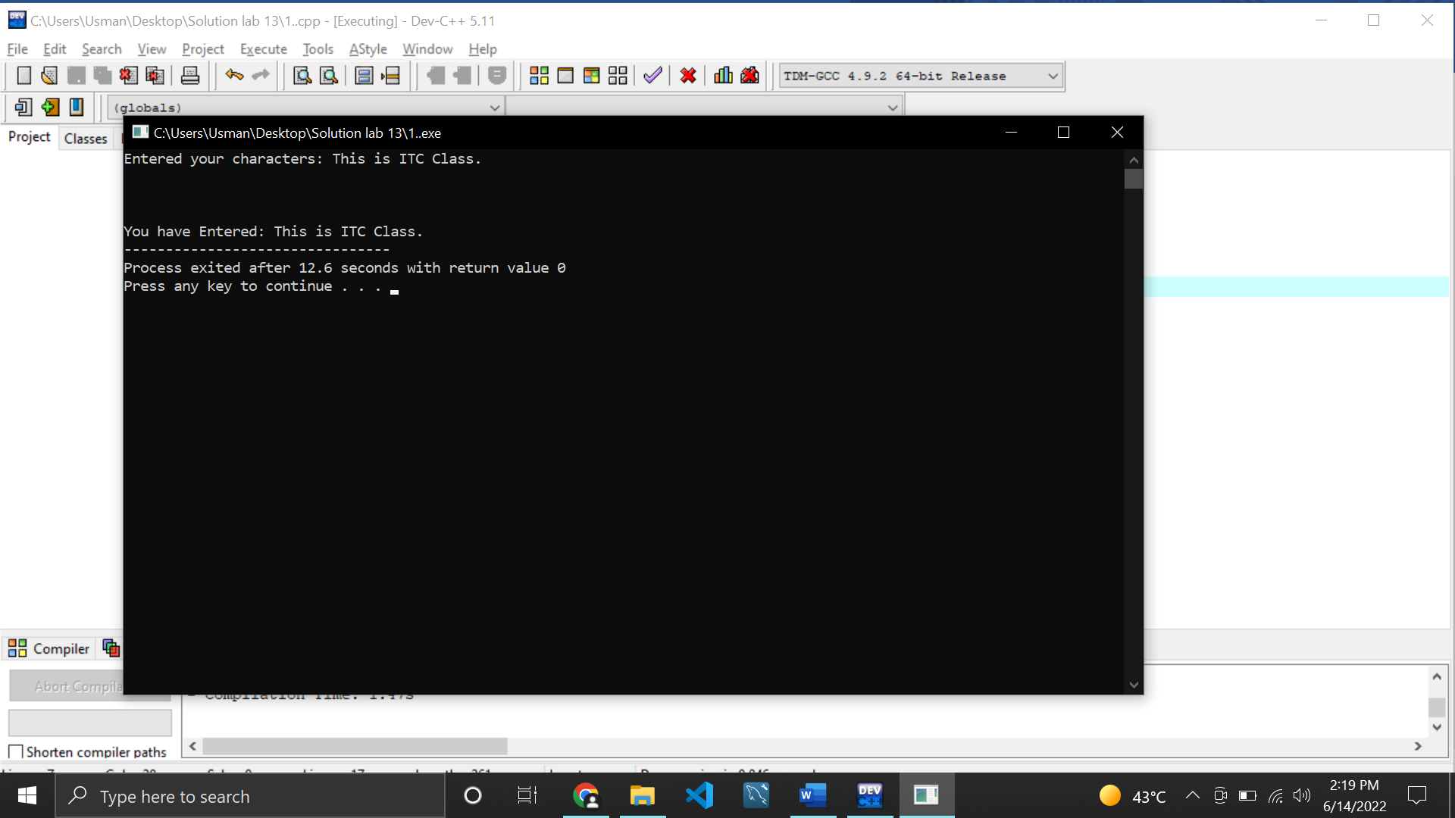

Task 6:
Create two arrays called Array1 and Array2. Initialize Array1 random characters. Array2 is blank and same as size of Array1. Store and display Values of Array1 in Array2 but in reverse order.
Sample Output:
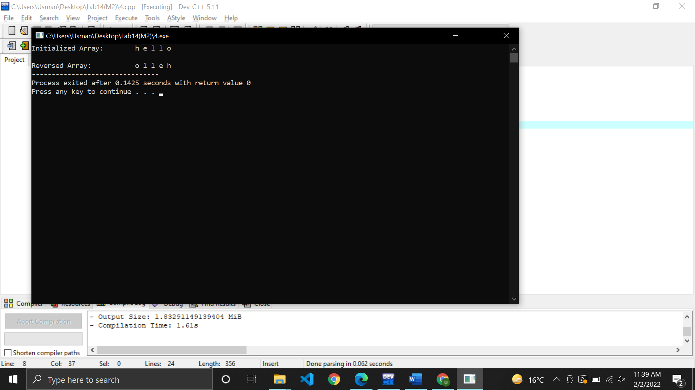

Task 7:

Write a program in which the user enters his/her name into the character array of size 20. Your program should store the character array into another array in reverse order.

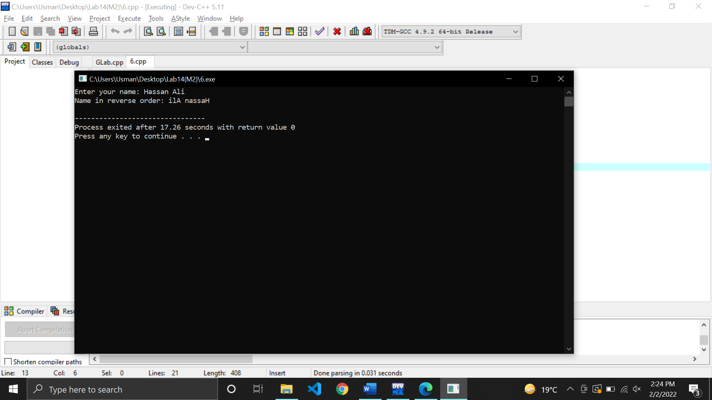

Task 8:

Write a program in which the user enters 10 characters in to an array. Your program should count the number of vowels in the array and also print the index at which they appear.

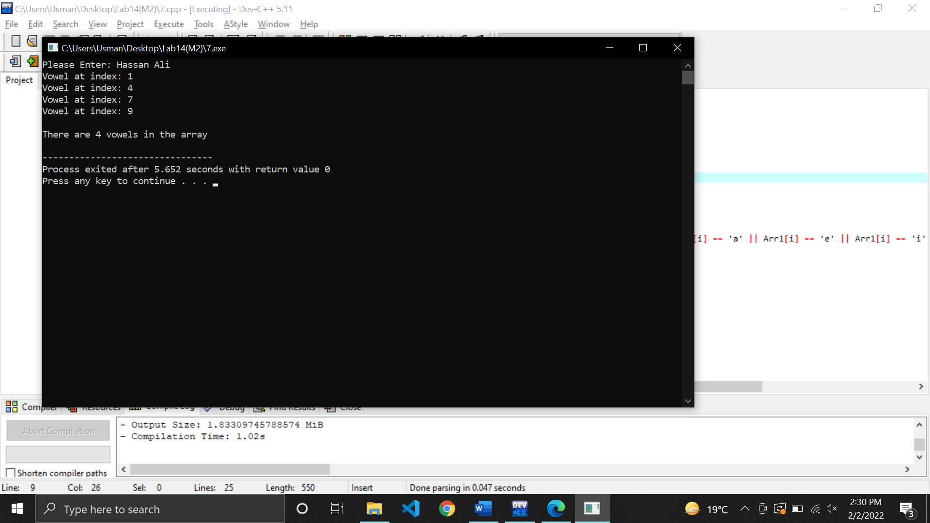

Task 9

Write a program that asks user to input your first name in first character array and input your sur name in second character array then your task is to merge both array data in third character array.
Example:
Input (from Console):
Enter first name: Ali
Enter Sur name: Ahmed
Output (on Console):
Complete name is: Ali Ahmed.

